# Animations

1. Animation using the transformation. Scale, rotate and translate.
2. Color animation
3. Door animation

## Frames

You may see that this screen is 30 frames per second. This you can define which creating the animation.

Let’s start with the basic animation. Drag and drop a sphere into the scene and apply any material to it. You can choose any material.

Applying the materail

Click on the **cinematics** this will allow you to add the animation to the object.

Add level sequence, is used if you want to you the animation inside one level.

Add master sequence, is used if you want to use the animation inside multiple levels.

Ones you click on the add level sequence it will prompt where you want to store the animation.

Lets say you save the animation. Ones you save that it will prompt the below pop up.

Drag and drop that into the below window and it will be shown something like below

You can increase you animation period by click and then drag it will be increase you animation period.

If you can see the animation period is increased.

Click on the object on which you want to add the animation and then click on the Track and click on the actor to sequence and finally click the selected object.

Ones you click and then you see various properties attached to this particular object.

You can see the New Level Sequence.

Now Let’s first add the location animation and then add the rotation animation to it.

Below are the properties where you can see different feature to the animation.

Let’s click on the + symbol of the animation and you will see a dot inside the sequencer.

One you click on the final then you can see a line and finally click on the play button inside the sequencer and you will see the animation of the object.

Click on the **New level sequence**, you will see the associated options below if you want to play the animation when you click on the play button then you can do by pressing auto play and you have bunch of other options as well which you can explore.

You have this graph which you can use for rotation and location points if your default rotation is not working.

Right click and then properties and you have bunch of other options to explore.

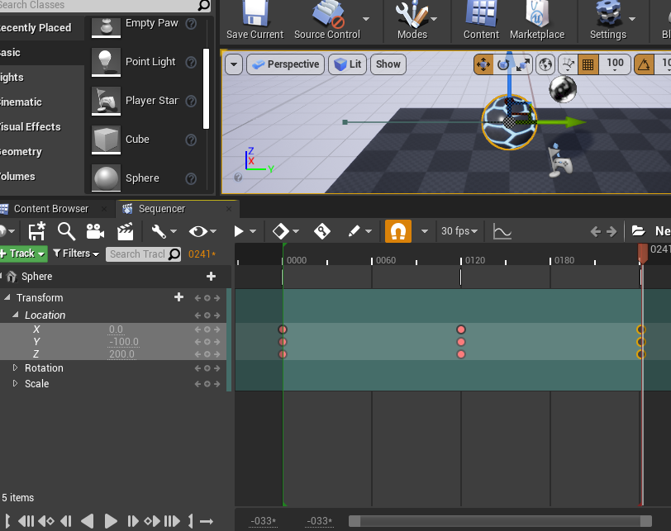

If you want to move the animation back and forth then you can add the key to its initial position and then you click on the middle one and finally you copy and paste the initial to its final and it will keep going from initial to find and you can create beautiful animation from the sequence.

## Second example

First create a material and save it. Let’s create a parameter for the material parameter collection.

Create a new parameter by pressing plus and then gave a name to its parameter name and provide a value to it.

Now drag and drop into the material and there you see **Parameter Name** none changed it to the name which you created earlier. Now create a **hue shifter** **node** with the node with you created.

You material looks like something save this.

Now again create a new sequencer and then select the object and then add into the sequencer.

Then select that material which you created earlier.

Now you will see the parameter here.

You will see that your assign material value is shifted from the initial to other color now you can also add the other transformation to that material.

You can extend the material and then you can

Basically, you can create the material and then you can see what happen into the animation.

## Example Three

**Alt** and **middle mouse button** are used to change the pivot of the object.

You can set the pivot of the object.

Again create an animation for the door let’s go to cinematics and add to sequencer and then add that object to it and then add the key point for the rotation. Simple is that.

Now let’s add a trigger box which will result in opening of the door.

Click on the blueprint and then click on the open level blueprint.

Ones you click you will see something like this. Delete both and then select the trigger box from the scene and finally

Then, you can add the collision on which you want to trigger the event.

Created both begin and end events.

Create a reference to the animation, how it comes basically it comes when you select the animation which you created from the scene. And then select the play sequence player from the below blueprint.

For reverse the animation, select the play reverse

Now let’s click on the play and see how it behaves.